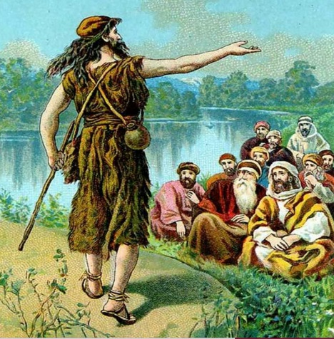
Looking for Jesus
So many people, just like Gebre and Onisa, have looked for Jesus! Even when Jesus was still in Jerusalem, people from other countries looked for him. During a festival, men from Greece looked for the apostle Philip. They said to him, “Sir, we wish to see Jesus!” (John 12:21)

John the Baptist sees Jesus. “Behold, the Lamb
of God! (John 1:29)

Why do you think the peddler described Jesus as “perfectly white”? The people of Sido had never heard of a white man. Gebre and Onisa were excited to find Mr. McLellan, but disappointed that he was not Jesus. How happy they were to hear about the real Jesus!
Jesus was born in Bethlehem, and grew up in Nazareth. He and his family were Jews. What do you think Jesus looked like? Explain your answer. _____________________________________________________________________________

When Jesus was alive, many other people looked for the Savior or asked, “Are you Jesus?” Read the Bible verses listed below. Match the verses with the people who looked for Jesus. Write the letter in front of the verses in the blanks.

A. Mark 10:17 _____ Some Greek men

B. John 20:11-16 _____John the Baptist

C. Matthew 2:1-2 _____The wise men

D. Luke 19:19-23 _____Mary Magdalene

E. Matthew 2:1-2 _____A rich man

One of the disciples did not believe Jesus even when he saw him with his own eyes! Read John 20:24-29. Which disciple did not believe he was truly seeing Jesus? Why didn’t he believe? Explain your answer.
_____________________________________________________________________________

_____________________________________________________________________________

