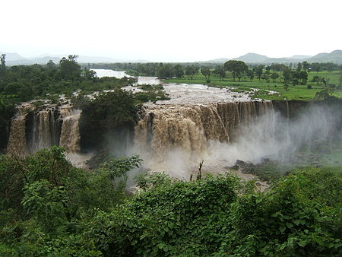
A Flood and a Fire

Sometimes writers use words to help you think of pictures inside your head. A simile compares two things using the word like or as. A metaphor is gives an even stronger picture, saying that the two things are the same!
Blue Nile Falls in the Amhara region of Ethiopia. It is also known as Tis Abay, which means “smoking water.”

In Chapter 1, “The Fire and Flood of God,” we read that the Good News of the Gospel is a gift. That is why the apostles and other Christians carried and shared it, one by one, to many other people, and to you!
What else is the gospel, the good news of free salvation, compared to? Write an S next to a simile, and M next to a metaphor.
_____The gospel is a treasure. _____The gospel is a mighty wind.
_____The good news is like a roaring blaze. _____The good news took root like a forest.
_____Jesus’ words are a rushing river. _____Jesus’ good news is a raging blaze.
_____The gospel is a fire taking hold. _____The gospel is like a fountain of life.

There are many other similes and metaphors in God’s Word. Look up the Bible verses below and write the similes and metaphors you find.
Matthew 13:44________________________________________________________________
Psalm 119:105_________________________________________________________________
John 10:11___________________________________________________________________
Matthew 5:14________________________________________________________________
John 4:14: “But whoever drinks of the water that I will give him will never be thirsty again. The water that I will give him will become in him a spring of water welling up to eternal life.” How can you be a “spring of living water”? ______________________________________________
_____________________________________________________________________________

