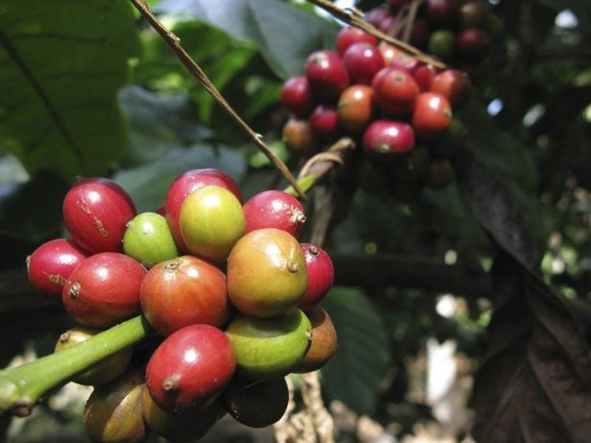The Birthplace of Coffee

Kebede's people brewed a drink from coffee leaves, called *koti,* the same way we would make tea*.* They had no idea the “kaffa bun” or fresh coffee bean pods, were worth keeping. Some did enjoy chewing the young coffee beans like gum, then spitting them out.

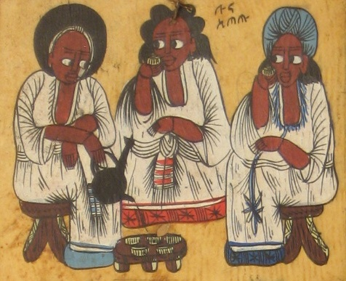Some people call Ethiopia “the birthplace of coffee." Even the word coffee comes from the Ethiopian word *kaffa*. Coffee shrubs grow wild in the Kaffa region of Ethiopia. Many believe that coffee was spread to other parts of the world when traders took slaves through the forests. The slaves could have chewed the beans, and spit them out along the trade routes.

Coffee is made in a *jabena,* a traditional Ethiopian coffee pot. The person making the coffee roasts the beans in front of guests. They grind the beans in a traditional container called a *mokecha*. Then they brew the coffee in a jabena, walking around the room so everyone can smell the delicious brew! They serve the coffee in small cups called *si'ni*. Most people add sugar and or even salt in their coffee! Others like to add *niter kibbeh,* a kind of butter, instead of sugar or salt.

Many Ethiopian words used describe coffee, coffee tools, and the kind of things people like to add to their drinks. Define each Ethiopian word associated with coffee.

Jabena ________________________________________________________________

Kaffa bun ________________________________________________________________

Si’ni ________________________________________________________________

Mokecha ________________________________________________________________

Koti ________________________________________________________________

Niter kibbeh ________________________________________________________________